Code: Flex Balls 4
Send Feedback

So now we are back with those rigid balls and smaller box. But the good news is that we have 2 boxes now instead of one.

So now you need to arrange them in the below provided fashion -
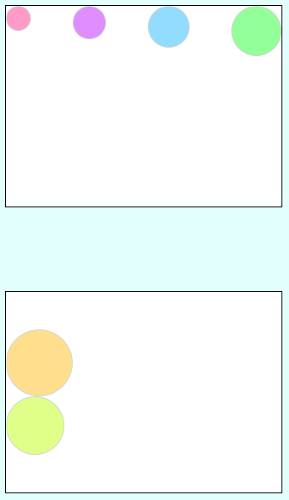

You can also try the following pattern -
